Goals: topics for next quiz

Lab2 explorations

Timing

Resource usage (memory)

Long division Latex Macro

Endianness

Numeric ranges

Two’s complement

Local variables

Symbols

How much storage does it take?

Program when running is called a process. It uses resources such as memory (RAM) (Registers, Cache)

$ CPU time

It may access hard drive.

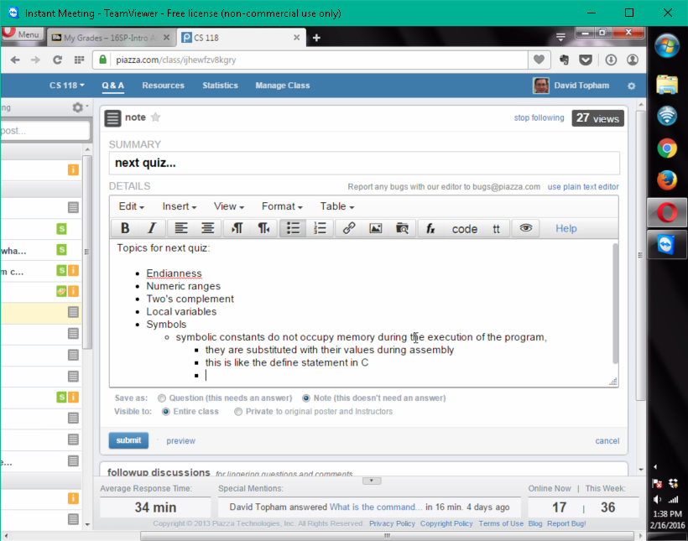

4 segments or sections

Anything starting with period is assembler directives.

.Text executable code

.Data global initialized r/w data

.Rodata read-only initialized data

.bss uninitialized data

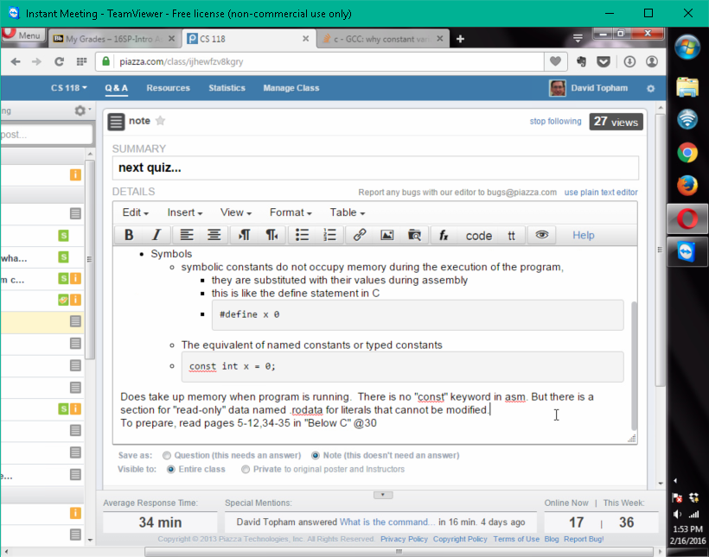

Symbolic constant

#define x 0

v.s.

const int x = 0;

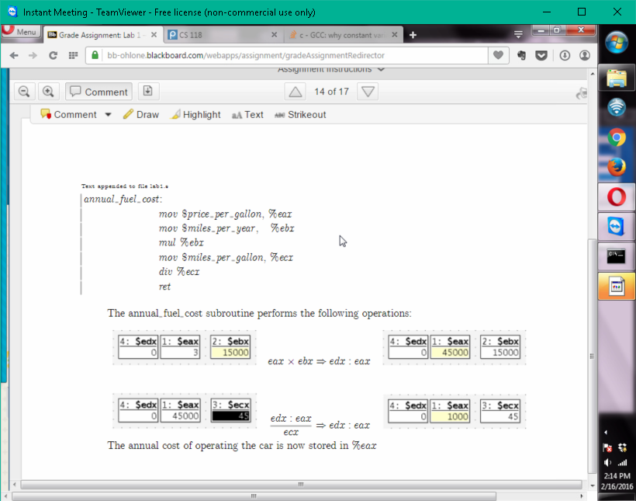

Assignment

int x;

x = 2;

initialization

int x = 2;

divisor ecx

quotient eax

dividend dex:eax

remainder edx

texfot

perl script to filter out informational messages from Latex.

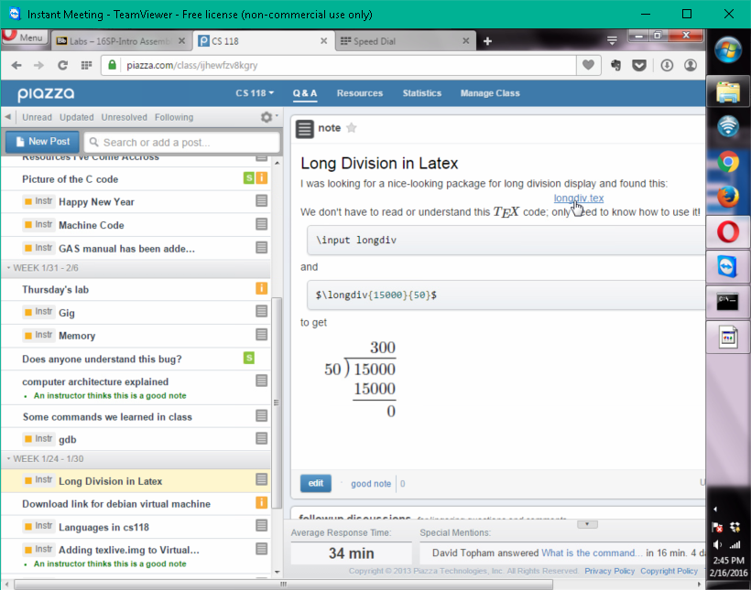

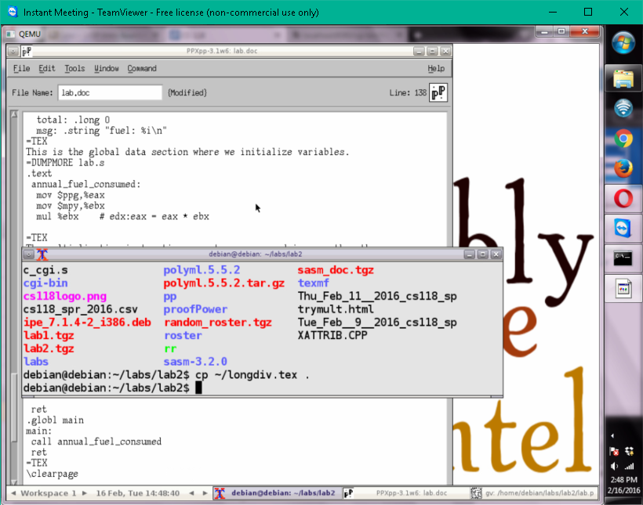

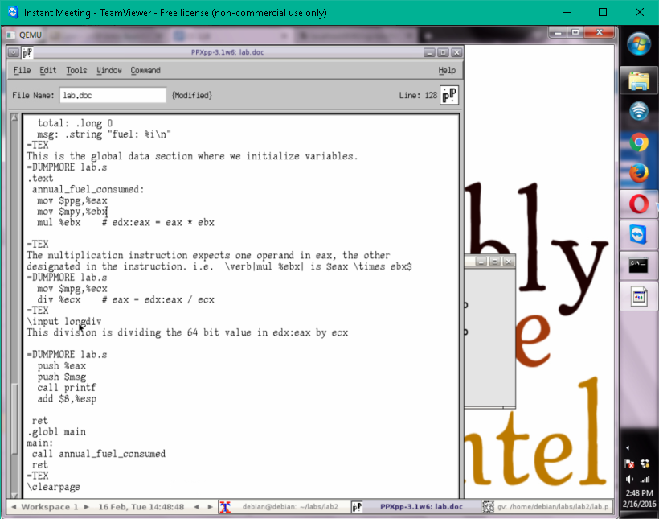

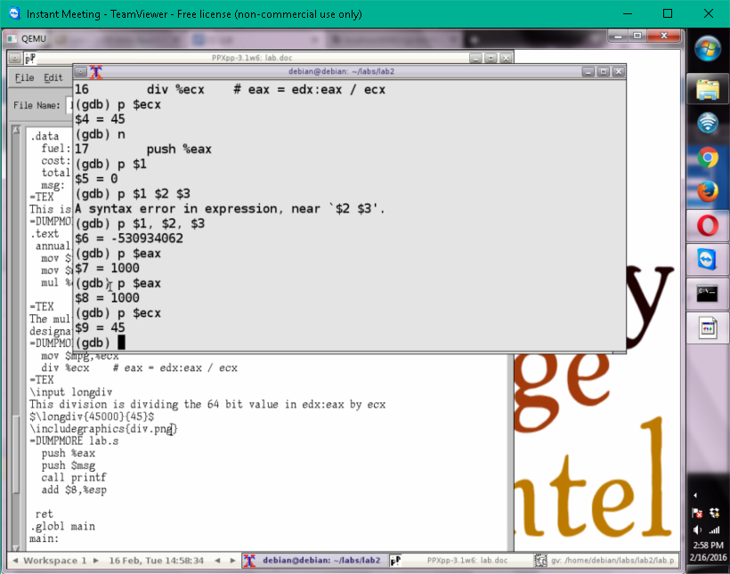

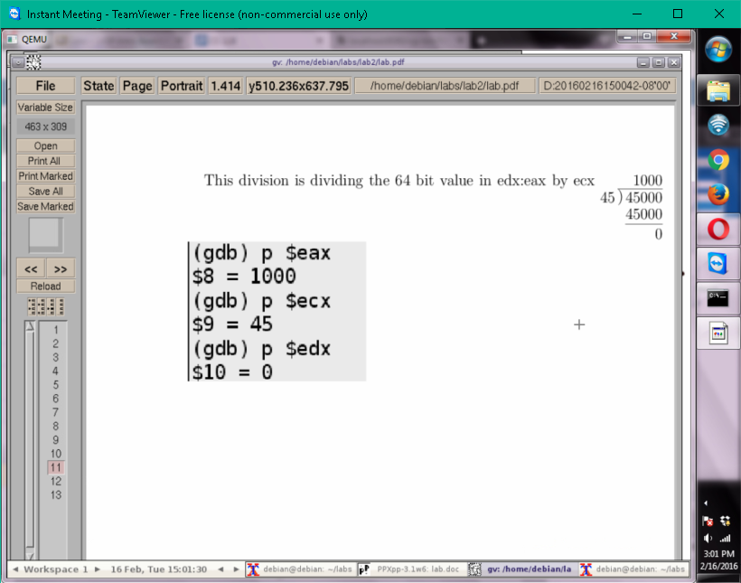

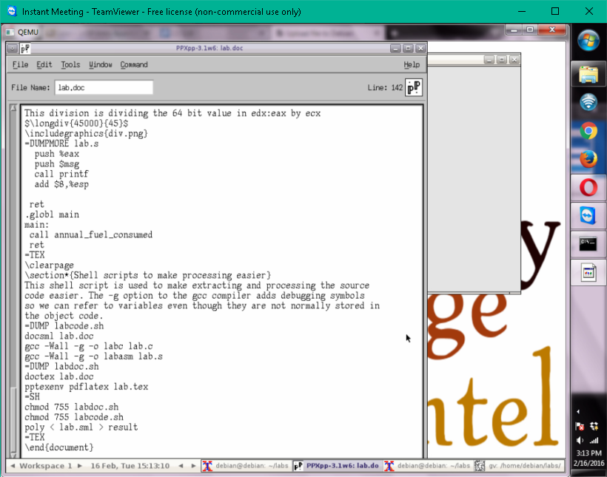

cd labs

mkdir lab2

cp lab1/\* lab2

cd lab2

xpp –f lab.doc –c poly

./labcode.sh

./labdoc.sh

Gv lab2.pdf &

Memory leaks

Valgrind

Machine code

Objdump

File info

File <prg>

Strings

String <prg>

Size

Size <prg>

Locations in file

Nm <prg>

Illegal memory access

Electric fence

